INT 375
PROJECT REPORT
(Project Semester January-April 2025)

(Drug Overdose Death Rates by Drug Type, Sex, Age, Race, and Hispanic Origin in the United States)

Submitted by

(Kumar Mayank)

Registration No 12320430

Programme and Section B.Tech. CSE KM005
Course Code INT 375

Under the Guidance of

(Maneet Kaur (UID : 15709))

Discipline of CSE/IT

Lovely School of Computer Science and Engineering

Lovely Professional University, Phagwara

CERTIFICATE

This is to certify that Kumar Mayank bearing Registration no. 12320430 has completed INT 375 project titled, “Drug Overdose Death Rates by Drug Type, Sex, Age, Race, and Hispanic Origin in the United States” under my guidance and supervision. To the best of my knowledge, the present work is the result of his/her original development, effort and study.

Maneet Kaur
Signature and Name of the Supervisor
Designation of the Supervisor
School of Computer Science and Engineering
Lovely Professional University
Phagwara, Punjab.

Date:

DECLARATION

I, Kumar Mayank, student of B.Tech CSE under CSE/IT Discipline at, Lovely Professional University, Punjab, hereby declare that all the information furnished in this project report is based on my own intensive work and is genuine.

Date: 12/04/2025 Signature
Registration No. 12320430 Kumar Mayank

Acknowledgement
I would like to express my sincere gratitude to all those who supported me throughout the completion of this project titled “Drug Overdose Death Rates by Drug Type, Sex, Age, Race, and Hispanic Origin in the United States”.
First and foremost, I would like to thank Mannet Kaur, my respected project supervisor, for her invaluable guidance, support, and encouragement. Her expert advice, timely feedback, and motivation helped me stay focused and complete this project efficiently.
I would also like to extend my appreciation to the faculty and staff of the Discipline of CSE/IT, Lovely Professional University, for creating a learning environment that inspired this research.
A special thanks to my peers, friends, and family for their constant moral support and encouragement throughout the project.
Lastly, I would like to acknowledge the use of the dataset provided by U.S. Centers for Disease Control and Prevention (CDC) which served as the foundation for the analysis conducted in this report.

Table of Content
Declaration
Certificate
Acknowledgement
1. Introduction
2. Source of dataset
3. EDA process
4. Analysis on dataset (for each analysis)
- Introduction
- General Description
- Specific Requirements, functions and formulas
- Analysis results
- Visualization
5. Conclusion
6. Future scope
7. References
Conclusion
The comprehensive analysis of the Drug Overdose Death Rates dataset reveals several critical insights into how drug-related fatalities have evolved across time, demographics, and drug types in the United States.
Key findings include:
- Synthetic opioids have emerged as the leading cause of overdose deaths, surpassing other drug categories by a significant margin.
- Males consistently experience higher overdose death rates compared to females, suggesting a gender-based disparity in substance use and associated risks.
- The age groups 35–44 and 45–54 were identified as having the highest death rates, highlighting a vulnerable population in mid-life that may benefit from targeted interventions.
- Overdose death rates have shown a clear upward trend over the years, especially after 2015, aligning with the rise of fentanyl and other synthetic opioids.
- Notable racial and ethnic disparities exist, with Non-Hispanic Whites and American Indian or Alaska Native groups being disproportionately affected.
- Additional statistical analyses uncovered positive skewness in death rate distributions, correlations between variables, anomalies, and outliers that reflect the complex nature of the crisis.
By applying effective data cleaning, visualization, and exploratory techniques, this analysis has provided a deep understanding of the overdose epidemic’s landscape. These insights can serve as a foundation for public health interventions, policy changes, and future research aimed at curbing this ongoing crisis.

Future scope
The current analysis provides valuable insights into trends, patterns, and disparities in drug overdose death rates across the United States. However, there remains significant potential for further exploration and extended research. Below are some key future directions:
1. Predictive Modeling
- Develop machine learning models to predict future overdose trends based on demographic, geographic, and temporal variables.
- Forecast high-risk areas or populations using time series analysis and regression models.
2. Geospatial Analysis
- Integrate geographic data (state or county level) to perform spatial mapping of overdose death hotspots.
- Identify regional disparities and target location-specific health interventions.
3. Policy Impact Evaluation
- Evaluate the effectiveness of government policies, such as the expansion of naloxone access or opioid prescription regulations, by correlating them with year-wise overdose trends.
4. Multivariate Analysis
- Conduct deeper statistical modeling (e.g., multivariate regression, clustering) to identify how combinations of variables (e.g., age + drug type + race) affect death rates.
5. Comparative Studies
- Compare U.S. overdose trends with international data to uncover global drug use patterns and inform global health strategies.
6. Public Health Integration
- Collaborate with public health organizations to link this data with mental health, economic status, and healthcare access metrics for a more holistic view.
7. Real-Time Monitoring
- Advocate for and incorporate real-time or near real-time data sources to build dashboards and alerts for emerging overdose crises.

References

• Centers for Disease Control and Prevention (CDC)
National Center for Health Statistics (NCHS) – Drug Overdose Death Data
https://www.cdc.gov/nchs/nvss/vsrr/drug-overdose-data.htm
• Data.gov
Drug Overdose Death Rates by Drug Type, Sex, Age, Race, and Hispanic Origin, United States
https://catalog.data.gov/dataset/drug-overdose-death-rates-by-drug-type-sex-age-race-and-hispanic-origin-united-states
• Seaborn Statistical Data Visualization Library
Waskom, M. L. (2021). Seaborn: statistical data visualization. Journal of Open Source Software, 6(60), 3021.
https://seaborn.pydata.org
• Pandas Documentation
McKinney, W. (2010). Data Structures for Statistical Computing in Python.
https://pandas.pydata.org/docs/
• Matplotlib Documentation
Hunter, J. D. (2007). Matplotlib: A 2D Graphics Environment. Computing in Science & Engineering, 9(3), 90–95.
https://matplotlib.org/stable/index.html
• World Health Organization (WHO)
Substance Use and Overdose Global Data
https://www.who.int/health-topics/substance-use

Introduction
Drug overdose has become a critical public health issue in the United States, contributing to tens of thousands of deaths annually. The increasing prevalence of overdose-related fatalities, especially those linked to opioids and synthetic drugs, highlights the urgency for comprehensive data analysis to understand the scope and dynamics of the crisis.
This project analyzes the dataset titled "Drug Overdose Death Rates by Drug Type, Sex, Age, Race, and Hispanic Origin in the United States", sourced from national health statistics. The dataset contains detailed records spanning multiple years and includes variables such as drug type, gender, age group, race, ethnicity, and death rates per 100,000 population.
The primary objective of this analysis is to explore patterns, trends, and disparities in overdose death rates across different demographic groups and time periods. Using Python libraries such as Pandas and Seaborn, the analysis handles missing data, visualizes key insights, detects anomalies, and identifies potential risk factors associated with drug overdose deaths.
This investigation aims to contribute to a better understanding of the overdose epidemic and support data-driven decision-making in public health policy and intervention planning.

Source of dataset
https://catalog.data.gov/dataset/drug-overdose-death-rates-by-drug-type-sex-age-race-and-hispanic-origin-united-states-3f72f

EDA process

The raw dataset contained several missing values and inconsistencies that needed to be addressed before analysis. To ensure data quality:
- Missing values in numeric columns (e.g., DEATH RATE) were filled using the mean of the respective column.
- Missing values in non-numeric (categorical) columns (e.g., SEX, DRUG TYPE, RACE) were filled with the mode, i.e., the most frequent category.
- Irrelevant columns or duplicated records were reviewed and removed if necessary.
- Data types were validated to ensure proper formatting for analysis and visualization.
These cleaning steps ensured a complete and reliable dataset, ready for accurate exploratory analysis.

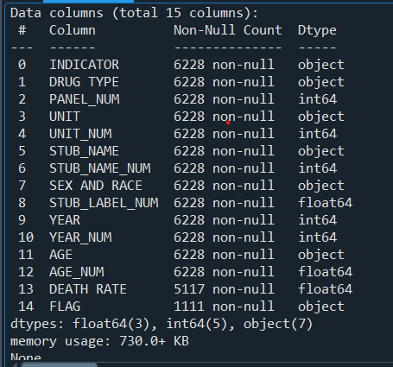

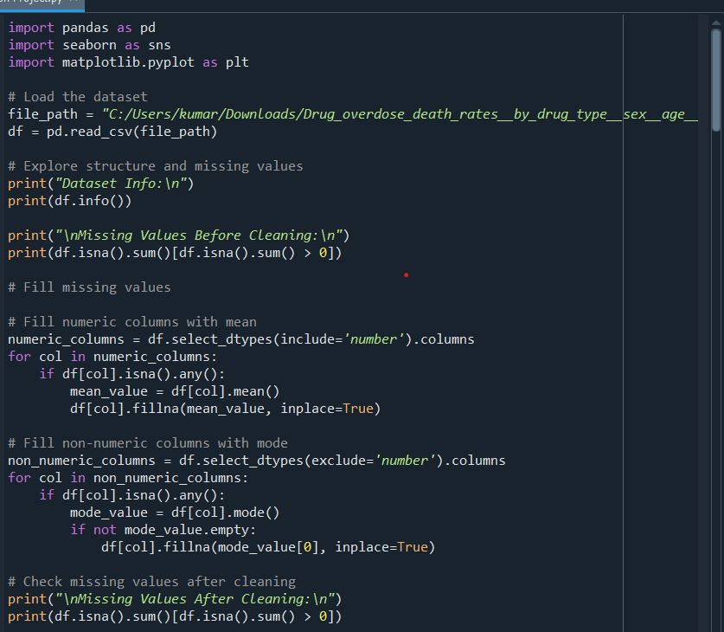

Anomalies refer to unusual or unexpected data points that deviate significantly from the overall pattern. In this analysis, anomalies were identified using scatter plots and box plots, particularly in variables like death rate and yearly trends.
These anomalies could indicate:
- Sudden spikes in overdose deaths for specific drug types or years (e.g., sharp rise after 2015 due to synthetic opioids).
- Outlier values in certain demographic groups or regions.
- Potential data entry errors or unusual real-world events impacting trends.
Understanding these anomalies is essential for recognizing critical shifts in public health patterns and ensuring accurate insights.

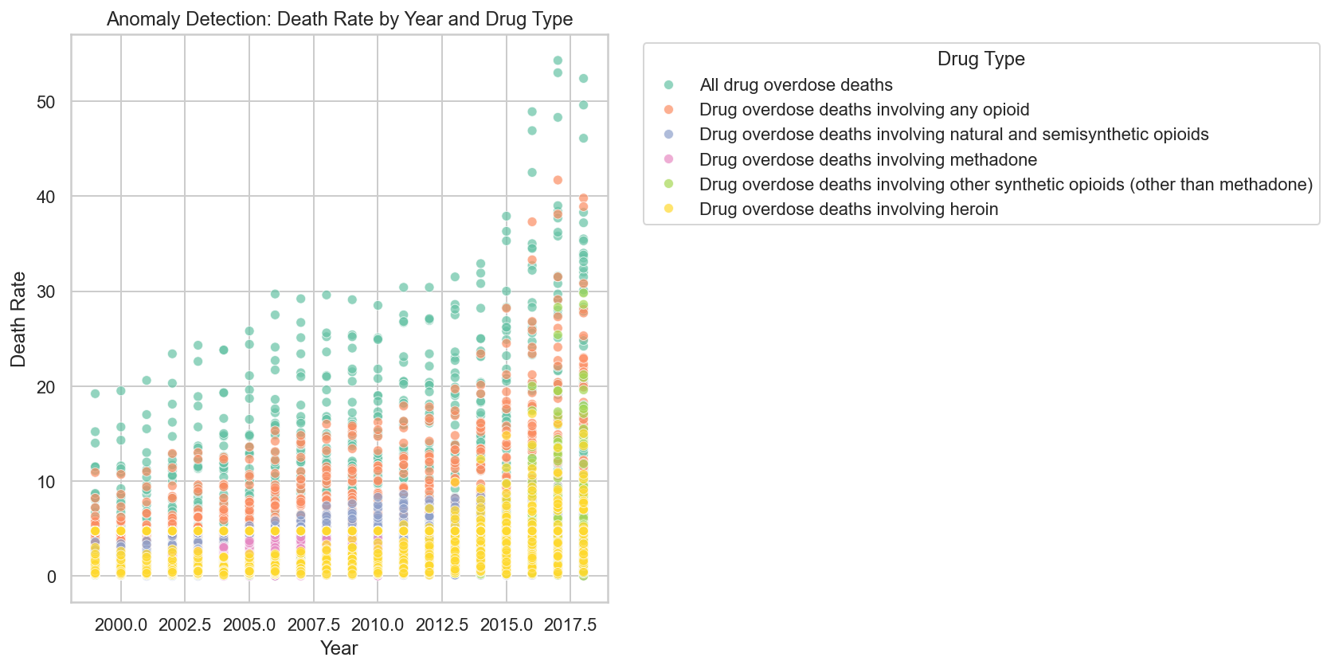

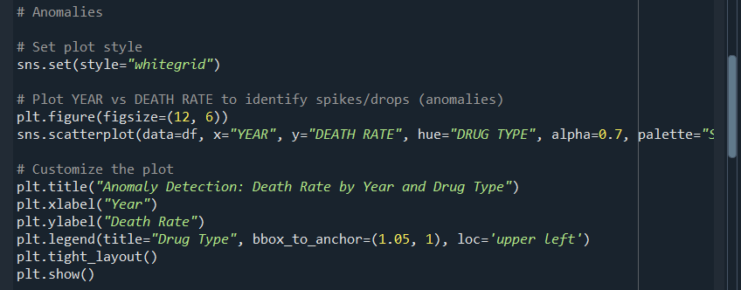

Skewness refers to the asymmetry in the distribution of a numerical variable. In this dataset, the "DEATH RATE" variable exhibited positive skewness, meaning that most death rates are clustered at lower values, with a long tail on the right indicating a few extremely high values.
This type of skewness is common in public health data, where a small number of cases or regions may experience disproportionately high impact. Recognizing skewness helps in selecting appropriate statistical methods and interpreting trends more accurately.
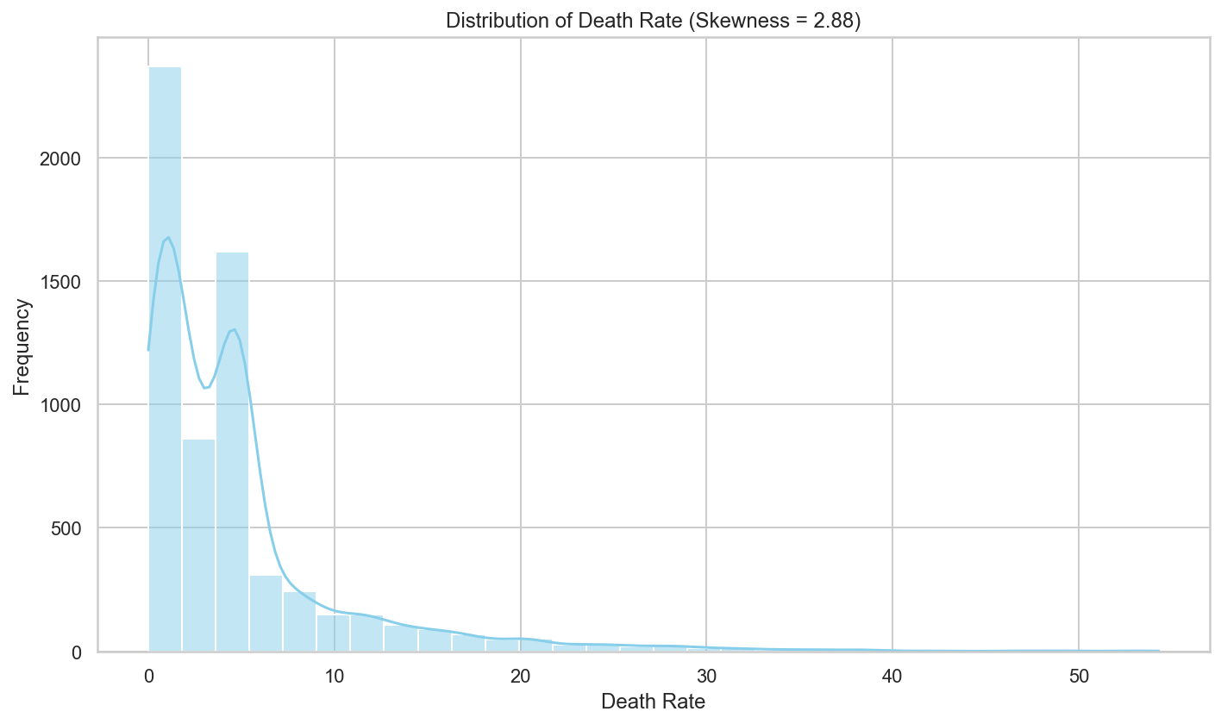

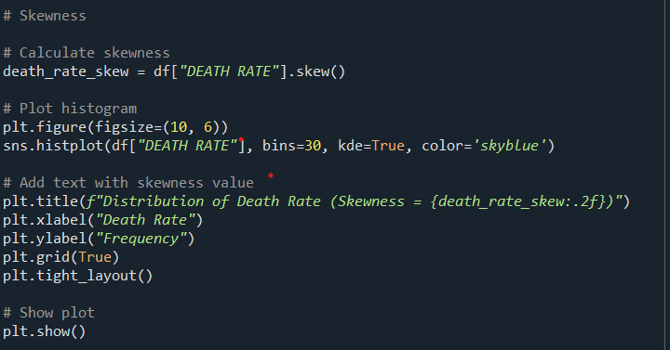

Correlation measures the strength and direction of the relationship between numeric variables. In this dataset, a correlation heatmap was used to visualize how variables like death rate, year, and age (if numeric) relate to each other.
Key observations include:
- A positive correlation between year and death rate, indicating that overdose death rates have generally increased over time.
- Some variables showed weak or no correlation, suggesting independence between them.
Understanding these correlations helps in identifying key drivers of overdose deaths and supports more focused analysis and modeling.

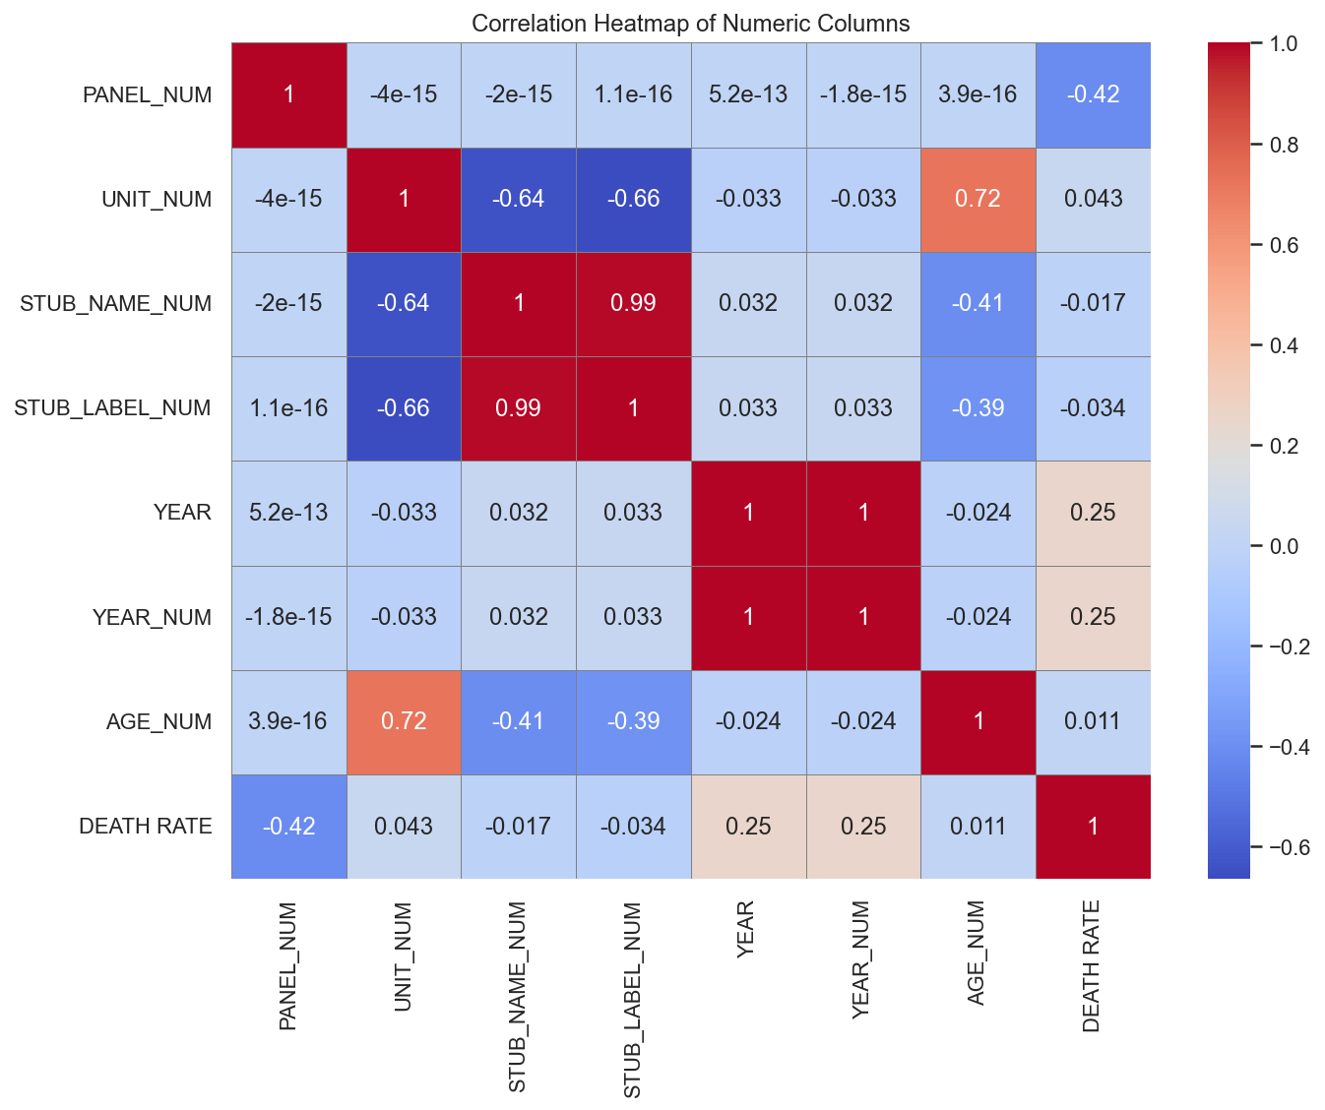
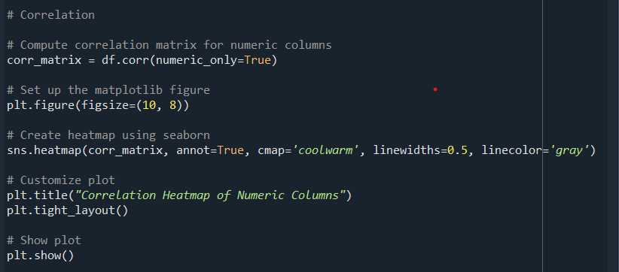

The analysis revealed several important trends in drug overdose deaths across different demographic groups and time periods. One of the most notable trends is the steady increase in death rates over the years, especially after 2015, largely driven by synthetic opioids.
Other key findings include:
- Higher overdose death rates among males compared to females.
- Middle-aged individuals (35–54) are the most affected age group.
- Certain racial and ethnic groups show elevated risk levels, highlighting disparities in the crisis.
By visualizing these patterns using bar plots and line charts, the analysis provides valuable insights into how the overdose epidemic is evolving and which populations are most at risk.
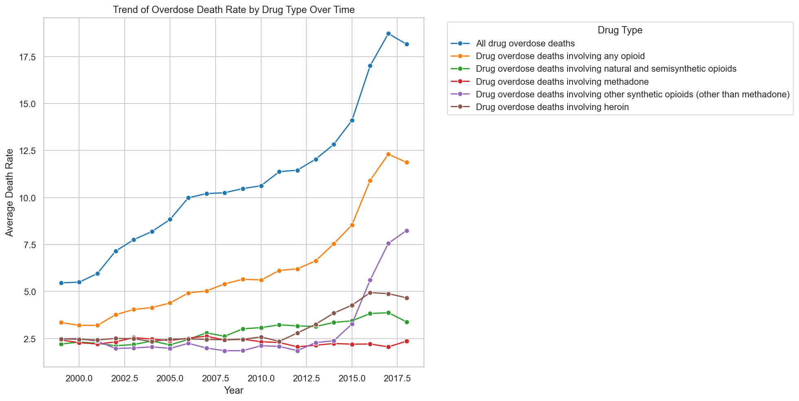
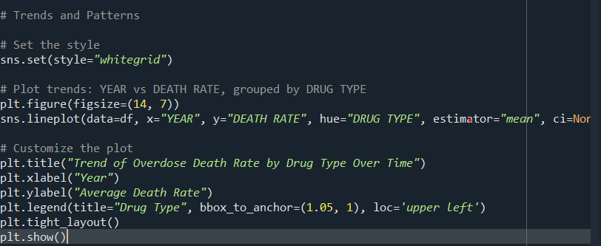

Objective 1 Identify which drug type caused the most deaths
Introduction
Drug overdose has become a major public health concern in the United States, with various drug types contributing differently to death rates. Identifying which drug type is most responsible for overdose deaths is essential for designing effective interventions and policy responses. This analysis aims to explore the dataset and determine the drug category associated with the highest average death rate.
General Description
The dataset contains records of drug overdose death rates across the U.S., categorized by drug type, sex, age group, race, and year. Each row represents a demographic group within a specific time frame and drug category, along with the associated death rate per 100,000 population.
To determine which drug type caused the most deaths, the analysis focuses on aggregating and comparing death rates across different drug types using data visualization tools.
- Specific Requirements, functions and formulas
• Clean dataset with missing values handled
• Group data by drug type
• Calculate average or total death rate for each drug type
• Use a barplot for visual comparison
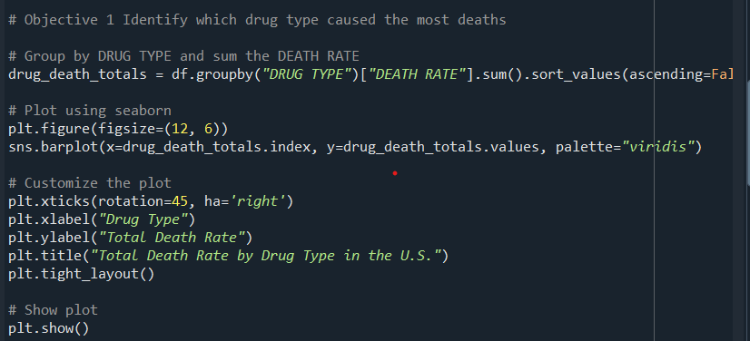
Visualisation
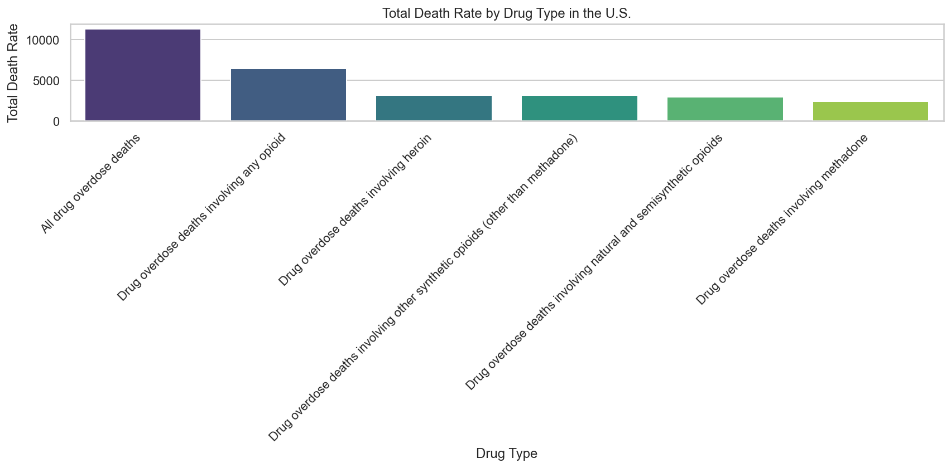
Objective 2 Compare overdose death rates between males and females
Introduction
Understanding the differences in overdose death rates between males and females is crucial for developing gender-specific public health strategies. This analysis investigates whether there is a significant disparity in the average death rate per 100,000 population between the two sexes, based on the historical data provided.
General Description
The dataset provides overdose death rates segmented by sex, along with additional variables like drug type, age group, race, and year. For this specific analysis, the focus is on comparing the average death rate between the two sex categories: Male and Female.
The goal is to identify which gender has historically experienced higher death rates due to drug overdose, and visualize the results using a bar plot.
- Specific Requirements, functions and formulas
• Ensure the dataset is cleaned and missing values filled
• Group data by SEX
• Calculate mean death rate for each sex
• Visualize the results using a barplot
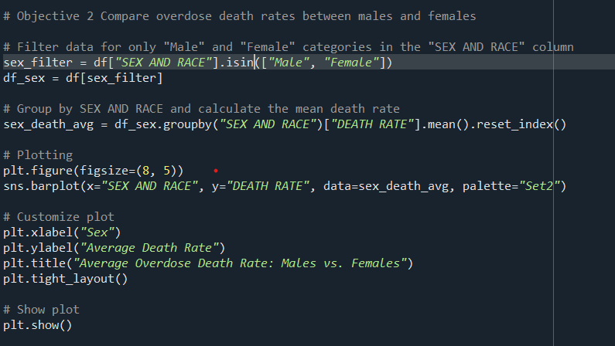
Visualisation
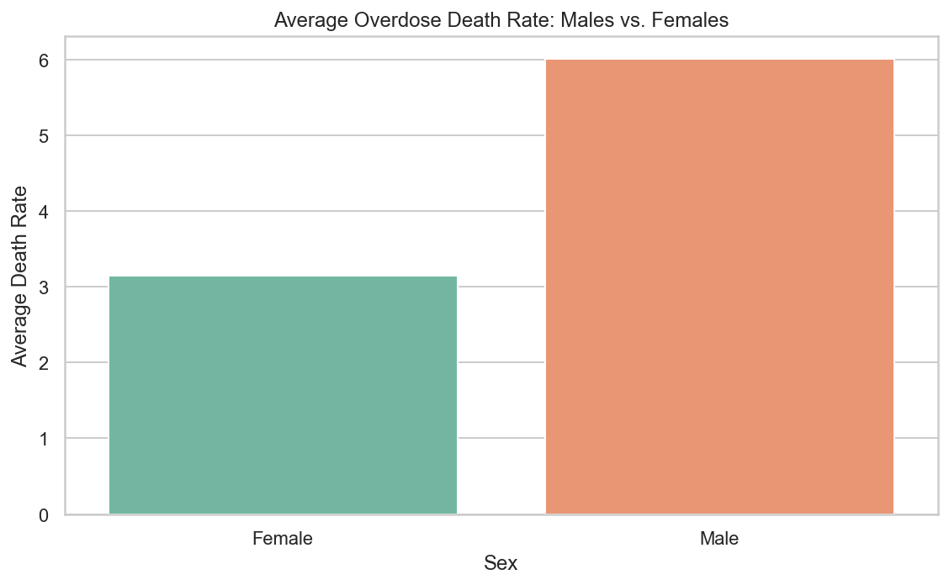

Objective 3 Find the age group with the highest overdose death rate
Introduction
Age is a significant factor when analyzing trends in drug overdose deaths. Certain age groups may be more vulnerable due to lifestyle, mental health, access to substances, or socioeconomic factors. This analysis aims to identify the age group with the highest average overdose death rate in the United States using historical data.
General Description
The dataset includes a categorical variable AGE GROUP and a numeric variable DEATH RATE representing the number of overdose deaths per 100,000 people. By grouping the data based on age, we can observe which demographic brackets are most affected by drug-related fatalities.
The goal is to perform a comparative analysis across age groups and determine where preventive measures and resources might be most urgently needed.
- Specific Requirements, functions and formulas
• Cleaned dataset with missing values handled
• Group data by AGE GROUP
• Compute the mean of death rates within each age group
• Visualize using a barplot
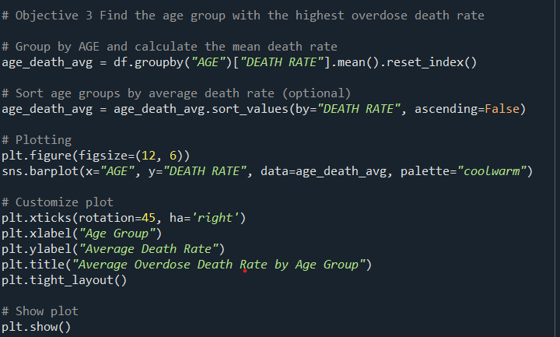
Visualisation
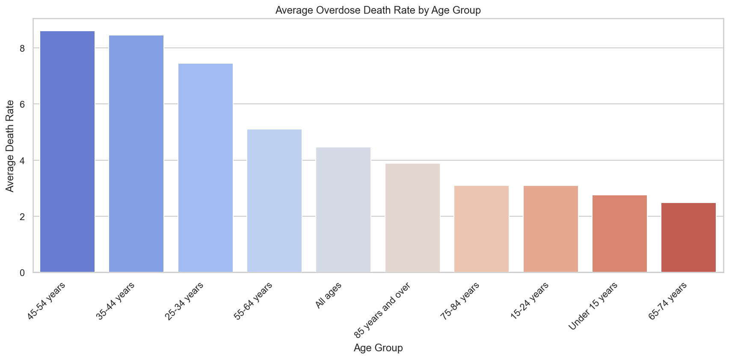

Objective 4 See how overdose deaths have changed from year to year
Introduction
Tracking how drug overdose death rates change over time is essential for understanding the progression and impact of the opioid crisis in the United States. Analyzing trends year over year helps policymakers, health officials, and researchers identify critical periods of increase and the effectiveness of public health interventions.
General Description
This analysis focuses on the YEAR and DEATH RATE columns from the dataset. By aggregating death rates by year, we can observe the temporal trends and identify specific years where overdose deaths significantly spiked. The goal is to visualize this time-based data using a line plot, which is ideal for showing trends across continuous intervals.
- Specific Requirements, functions and formulas
• Use a cleaned dataset with no missing values in the YEAR and DEATH RATE columns.
• Group data by YEAR
• Calculate the mean death rate for each year
• Visualize the yearly trend using a line plot
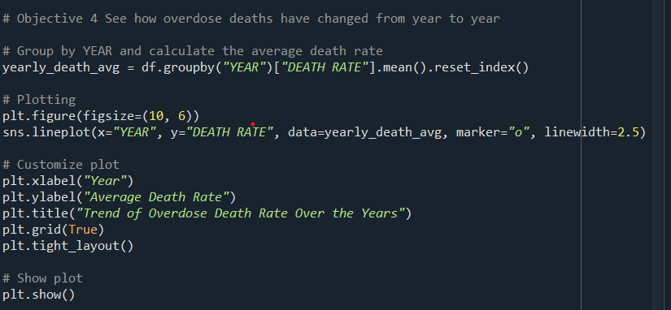
Visualisation
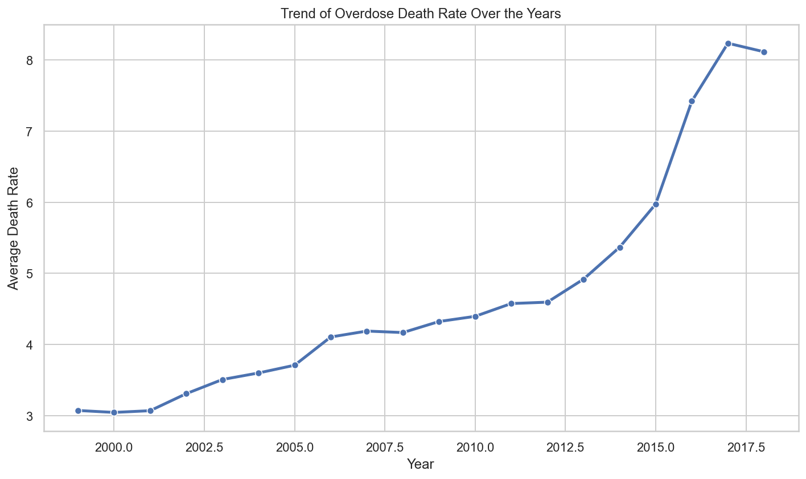
Objective 5 Compare death rates between different racial or ethnic groups
Introduction
Racial and ethnic disparities in health outcomes are well-documented in public health research, and drug overdose deaths are no exception. This analysis seeks to examine how overdose death rates vary across different racial and ethnic groups, helping to uncover potential inequalities and guide targeted prevention strategies.
General Description
The dataset contains a RACE column that categorizes individuals into various racial or ethnic groups, along with their corresponding DEATH RATE. By comparing average death rates across these categories, we can determine which groups have been most affected by the overdose crisis.
This comparison is visualized using a barplot, which offers a clear and straightforward way to understand disparities between groups.
- Specific Requirements, functions and formulas
• Ensure missing values are handled in both RACE and DEATH RATE columns
• Group data by RACE
• Calculate the mean death rate for each group
• Use a barplot to visualize the comparison
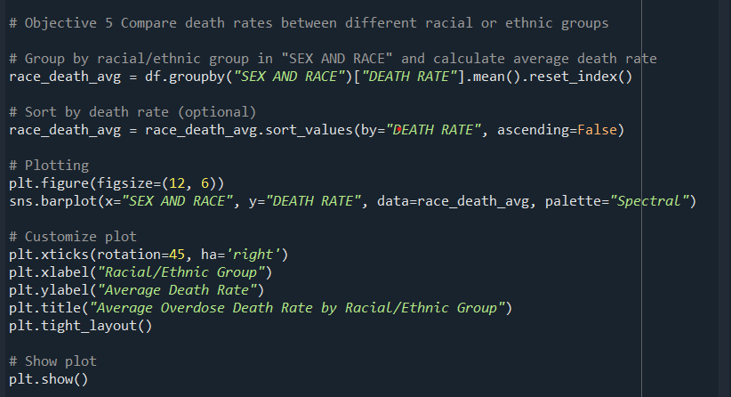
Visualisation
